Question 2
- Network topology: 1 hidden layer
  - Input layer: M = 784 neurons
  - Hidden layer: N = 30-50 neurons
  - Output layer: L = 10 neurons
- To represent digits 0,...,9: I use the same setup as in Homework 2.
- Activation functions:
  - tanh function for the hidden neurons
  - q(v) = 1/10 * v for the output neurons (or 1/5 * v)
- Energy function: D(. , .) is chosen as suggested in the problem. The energy function is the average of all the D distance between desired output and network output.
- I chose 1 hidden layer as I believe 2 hidden layers is not neccessary for this problem.
After playing around with number of hidden layers, I noticed 10 neurons is not enough for a good classification, and more than 50 does not give a better result to make up for the longer running time, thus N = 30, 40, or 50 is a good choice.
- I started with learning rate eta = 0.7, but I noticed the energy function goes up at some points. I decrease to eta = 0.5 but same thing happens again. Eventually I am happy with eta = 0.1.
I started with q(v) = v for the output neurons but the algorithm did not converge, so I decided to play around with it by a scaling constant, and 1/5 or 1/10 is a suitable scale.
I tried with different number of max_epochs ranging from 30 to 200, and I used threshold = 0.05 or 0.1 for early stopping of energy function.
- Result:
  - For N = 30, max_epochs = 70, threshold = 0.05, eta = 0.1
Error Rate for Training Data: 5.9%
Error Rate for Testing Data: 7.4%
  - For N = 50, max_epochs = 70, threshold = 0.05, eta = 0.1 (This is the final choice that I used for the plots below)
Error Rate for Training Data: 3.78%
Error Rate for Testing Data: 5.71%
  - For N = 50, max_epochs = 150, threshold = 0.05, eta = 0.1
Error Rate for Training Data: 4.1 %
Error Rate for Testing Data: 6.2%
- Pseudocode: Please check my code directly as I have commented my code really detailed for this interesting question.
- Plot 1 (# epoch vs # classification error rate for training set)
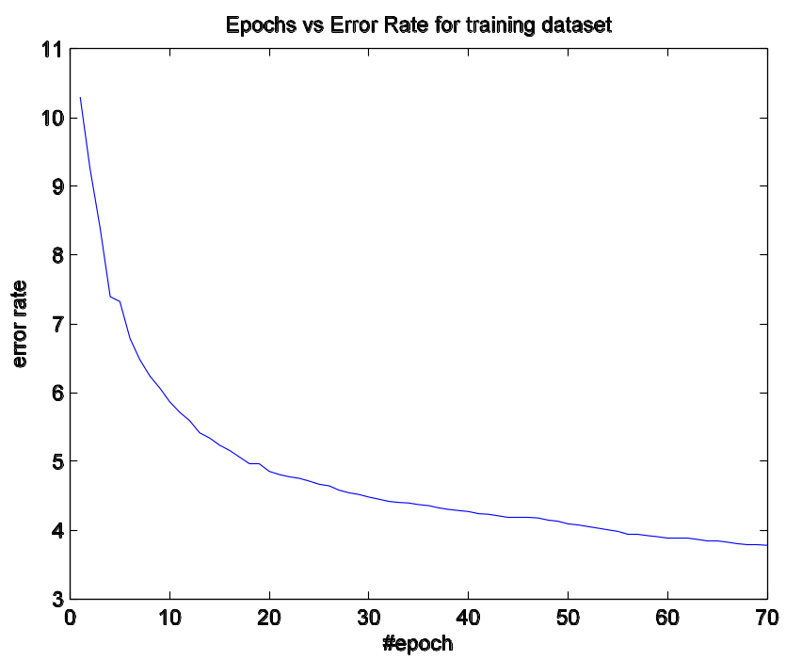
- Plot 2 (# epoch vs # classification error rate for testing set)
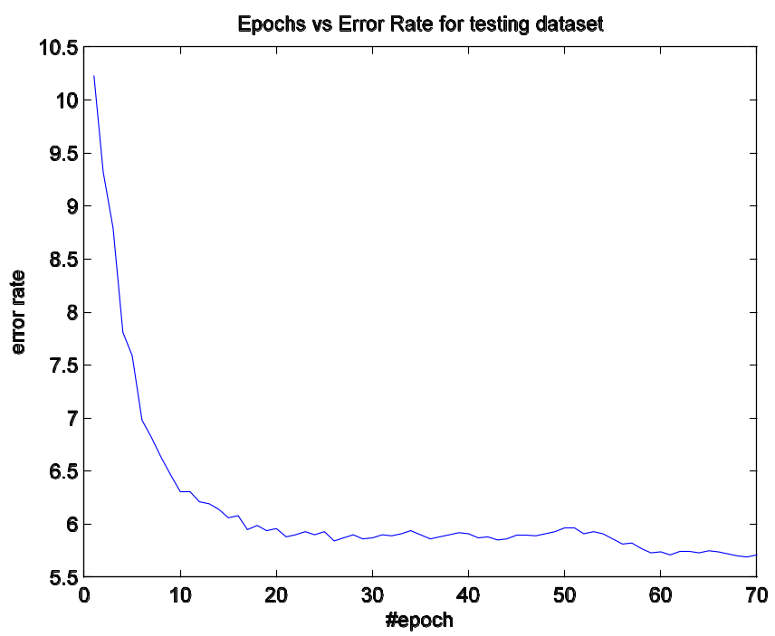
- Plot 3 (# epoch vs energy function for training set)
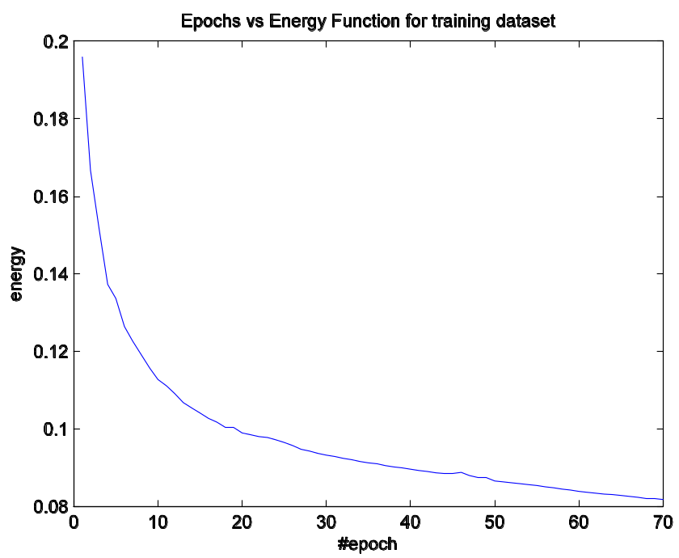
- Plot 4 (# epoch vs energy function for testing set)
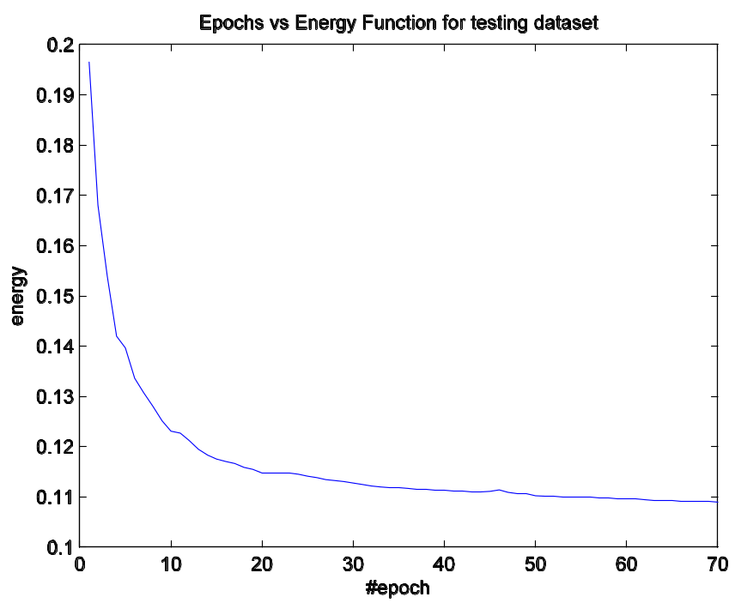
- Code
%%
clc
close all
clear all

%%%%%%%%%%%%%%%%%%%%%%%%%%%%%%%%%%%%%%%%%%
% INITIAL SETUP
%%%%%%%%%%%%%%%%%%%%%%%%%%%%%%%%%%%%%%%%%%

% load data
trainingImages = loadMNISTImages('train-images.idx3-ubyte');
trainingLabels = loadMNISTLabels('train-labels.idx1-ubyte');
testingImages = loadMNISTImages('t10k-images.idx3-ubyte');
testingLabels = loadMNISTLabels('t10k-labels.idx1-ubyte');

% number of input neuron
M = 784;
% number of hidden neuron
N = 50;
% number of output neuron
L = 10;

% possible desired output (given in form of identity matrix)
iden = eye(10); % d(1) = [1 0 ... 0]' is 0, d(2) is 1, ..., d(10) is 9

% Extract a subset of the training images to test the method
n_train = 60000; % size of training subset, 60000 is full training set
trainingImagesSubset = trainingImages(:, 1:n_train);
trainingLabelsSubset = trainingLabels(1:n_train);

% Extract a subset of the testing images to test the method
n_test = 10000; % size of training subset, 10000 is maximum
testingImagesSubset = testingImages(:, 1:n_test);
testingLabelsSubset = testingLabels(1:n_test);

% input layer, rename to match with backpropagation algorithm and for convenience
x_train = trainingImagesSubset;
x_test = testingImagesSubset; % input layer for testing case

% Match training label to the right form of desired output
d_train = zeros(L, n_train);
for i = 1:n_train
d_train(:, i) = iden(:, trainingLabelsSubset(i)+1);
end

% Match testing label to the right form of desired output
d_test = zeros(10, n_test);
for i = 1:n_test
d_test(:, i) = iden(:, testingLabelsSubset(i)+1);
end

max_epochs = 150; % # of maximum epoch
threshold = 0.05; % energy function threshold
eta = 0.1; % learning rate

% Initialize weights randomly, including biases
W1 = 2.*rand(N, M+1) -1;
W2 = 2.*rand(L, N+1) -1;

% raw form of network output for training case, distance function will be
% applied to classify into the right (predicted) label
y_train = zeros(L, n_train);
% raw form of network output for testing case, distance function will be
% applied to classify into the right (predicted) label
y_test = zeros(L, n_test);

% predicted labels for training set
predicted_train = zeros(L, n_train);
% Vector of error count and error rate with respect to epochs for training
trainErrorCountVector = zeros(max_epochs, 1);
trainErrorRateVector = zeros(max_epochs, 1);

% predicted labels for testing set
predicted_test = zeros(L, n_test);
% Vector of error count and error rate with respect to epochs for testing
testErrorCountVector = zeros(max_epochs, 1);
testErrorRateVector = zeros(max_epochs, 1);

% Energy function training vector for respective epoch
energy_train = zeros(max_epochs, 1);
% Energy function testing vector for respective epoch
energy_test = zeros(max_epochs, 1);

% previous energy value, rescale eta to a smaller if energy is increasing
previous_energy = 1;

%%%%%%%%%%%%%%%%%%%%%%%%%%%%%%%%%%%%%%%%%
%%% Begin training
%%%%%%%%%%%%%%%%%%%%%%%%%%%%%%%%%%%%%%%%%
for epoch = 1:max_epochs
for i = 1:n_train
% Backpropagation training
[W1, W2] = backPropagation(eta, x_train(:, i), d_train(:, i), W1, W2);
end

% Energy vector for training sample in one epoch
errorTrain = zeros(n_train, 1);

for i = 1:n_train
[v1, y1, v2, y2] = feedForwardNet(x_train(:, i), W1, W2);
errorTrain(i, :) = Dist(d_train(:, i), y2); % energy value at sample i
y_train(:, i) = y2; % network output of input sample i

end

% Energy vector for training sample in one epoch
errorTest = zeros(n_test, 1);
% compute network output for testing set
for i = 1:n_test
[v1, y1, v2, y2] = feedForwardNet(x_test(:, i), W1, W2);
errorTest(i, :) = Dist(d_test(:, i), y2); % energy value at sample i
y_test(:, i) = y2;
end

% count number of training error/ misclassification after one epoch
trainErrorCount = 0;
for i = 1:n_train
v = zeros(L, 1);
for j = 1:L
v(j) = Dist(y_train(:, i), iden(:, j));
end
[minimum, index] = min(v);
predicted_train(:, i) = iden(:, index);
if ~isequal(predicted_train(:, i), d_train(:, i))
trainErrorCount = trainErrorCount + 1;
end
end
% training error rate after one epoch
trainErrorRate = 100 * trainErrorCount/n_train;
% update error count and error rate vector
trainErrorCountVector(epoch) = trainErrorCount;
trainErrorRateVector(epoch) = trainErrorRate;

% compute error count and error rate of testing set
testErrorCount = 0;
for i = 1:n_test
v = zeros(L, 1);
for j = 1:L
v(j) = Dist(y_test(:, i), iden(:, j));
end
[minimum, index] = min(v);
predicted_test(:, i) = iden(:, index);
if ~isequal(predicted_test(:, i), d_test(:, i))
testErrorCount = testErrorCount + 1;
end
end
% testing error rate after one epoch
testErrorRate = 100 * testErrorCount/n_test;
% update error count and error rate vector
testErrorCountVector(epoch) = testErrorCount;
testErrorRateVector(epoch) = testErrorRate;

% Energy function is the mean of energy values of all samples
energy_train(epoch) = sum(errorTrain)/n_train;
% Energy function is the mean of energy values of all samples
energy_test(epoch) = sum(errorTest)/n_test;

% rescale eta in case energy is increasing
if (energy_train(epoch) > previous_energy)
eta = eta * 0.9;
end
previous_energy = energy_train(epoch);

figure(1);
plot(energy_train);
if energy_train(epoch) < threshold
break;
end

end

trainErrorRateVector(max_epochs)
testErrorRateVector(max_epochs)

%%%%%%%%%%%%%%%%%%%%%%%%%%%%%%%%%%%%
%%% PLOT
%%%%%%%%%%%%%%%%%%%%%%%%%%%%%%%%%%%%

% Plot of #epoch and energy function for training case
figure(1)
title('Epochs vs Energy Function for training dataset')
xlabel('#epoch')
ylabel('energy')
%Set PaperPositionMode to auto so that the exported figure looks like it does on the screen.
set(gcf, 'PaperPositionMode', 'auto');
print('-depsc2', strcat('Epochs vs Energy for Training', '-', date, '.eps'));

% Plot of #epoch and energy function for testing case
figure(2)
plot(energy_test)
title('Epochs vs Energy Function for testing dataset')
xlabel('#epoch')
ylabel('energy')
%Set PaperPositionMode to auto so that the exported figure looks like it does on the screen.
set(gcf, 'PaperPositionMode', 'auto');
print('-depsc2', strcat('Epochs vs Energy for Testing', '-', date, '.eps'));

% Plot of #epoch and training error rate
figure(3)
plot(trainErrorRateVector);
title('Epochs vs Error Rate for training dataset')
xlabel('#epoch')
ylabel('error rate')
%Set PaperPositionMode to auto so that the exported figure looks like it does on the screen.
set(gcf, 'PaperPositionMode', 'auto');
print('-depsc2', strcat('Epochs vs Error Rate for Training', '-', date, '.eps'));

% Plot of #epoch and training error rate
figure(4)
plot(testErrorRateVector);
title('Epochs vs Error Rate for testing dataset')
xlabel('#epoch')
ylabel('error rate')
%Set PaperPositionMode to auto so that the exported figure looks like it does on the screen.
set(gcf, 'PaperPositionMode', 'auto');
print('-depsc2', strcat('Epochs vs Error Rate for Testing', '-', date, '.eps'));

function [ dist ] = Dist( x, y )
% Distance function between desired output and network output in question 2
% Detailed explanation goes here
dist = 0;
for i = 1: length(x)
dist = dist + (x(i) - y(i))^2;
end
end

